
SOP Title: | eCommerce 3PL STO Inbound Process
Document Storage Location: | STACS/Management/SOPs – Logistics and Warehousing | Document #: | SEASOP387v100
SOP Originator: | Viraj Baraskar | Last Edited by: | Viraj Baraskar
Effective Date: | 07/31/2020 | Last Edited Date: | 07/31/2020
Other:

- Purpose
  - To identify and document the Stock Transfer Order (STO) issuing and receiving process within the Samsung Electronics America (SEA) eCommerce (eComm) department.

- Scope
  - Coppell – Process to occur when the Stock Transfer Orders(STOs) are created in SAP.

- Responsibilities
  - 3PL Management shall be responsible for ensuring that all employees receive proper training in the Goods Issue & Receiving procedures in accordance with this document.
  - SEA Operations team shall be responsible for providing support and resolution for system processing errors reported by 3PL.

- Instructions
  - The process begins when a Delivery Order(DO) is dropped by the Samsung Demand Fulfilment (DF) team for a particular stock keeping unit(SKU).
  - Once a delivery order drops, the North Dock 3PL team creates an STO for the material to go to eComm.
    - The 3PL team has an SLA of 24 hours to receive and put the STO away in location.
  - The SKU is then picked from location(s) for the quantity against the order. The SKU may be in stock at the Coppell warehouse or may be delivered to the warehouse from other locations.
  - Once the allocated quantity is picked, the STO is then systemically Goods Issued(GI-d).
  - The physical STO material is delivered from Finished Good warehouse to the eComm inbound floor.
  - 3PL uses colored cones as shown below to indentify the status of all the product on the floor.
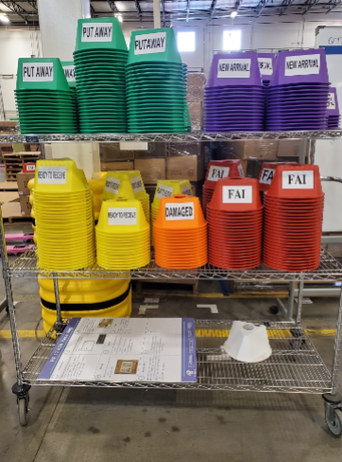

  - Once, the STO arrives on the floor, a purple cone is placed on the STO indicating that it is a new arrival on the inbound floor.
  - Validations:
    - The physical contents of the box are verified against the packing slip which is attached to the box of the STO.
    - The details of the packing slip are then also verified against the system.
  - Once both validations are complete:
    - If found accurate, a yellow cone is placed on the material indicating that the STO is now ready to be received.
    - If the details of the STO in the system do not match the packing list for any reason, a red cone is placed on the material indicating that some investigation is needed and the STO has a systemic issue.
      - The STO details are completely deleted in Synapse and STO issues are to be solved before they are GI-d again.
      - The new details are visible in the system after some minutes.
    - If the contents of the STO do not match with the SKU or the quantity mentioned on the packing slip, an orange colored damaged cone is used. The STO is sent back to the north dock for further work.
      - This cone is also used if the contents of the STO have physical and/or other visible damage.
  - Once the STO is ready to be received, the inbound receiving person put a licence plate ID on each carton.
  - To GR the STO material in Synapse, the inbound location is scanned, then scans the licence plate bar code and the carton ID is scanned.
    - A green cone is placed on the material indicating the material is ready to put away into a bin.
    - The system puts a Receipt Hold on the material pending put away.
  - To put away the material, the 3PL personnel scans the inbound location again and physically moves the material to the new bin location.
    - The new location and the carton ID are both scanned to complete the put-away.
    - If the scan is not done correctly, the Receipt Hold will remain on the material.

